CV Showcase Web Page

# Six Key Design Features and their Implementation

202115030121 Yang Hao UC_CS211

* **Get form information from local Storage without duplication**

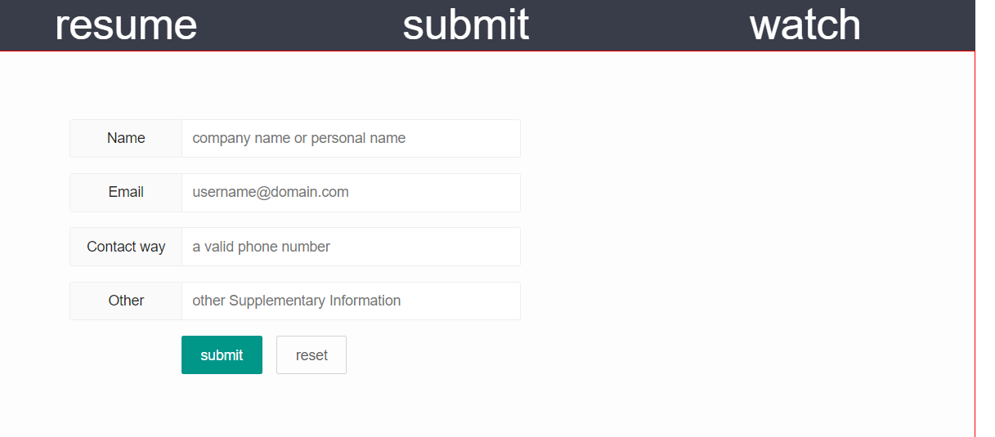

In image_map.html, when accessing data in the localStorage, the length of access cannot start at 0 because tables may have been dynamically added to the “watch” page. Therefore, to find the number of rows that have been dynamically added, start with the first data that has not been accessed.





But view_CV_requested.html must start from zero, regardless of the current length.

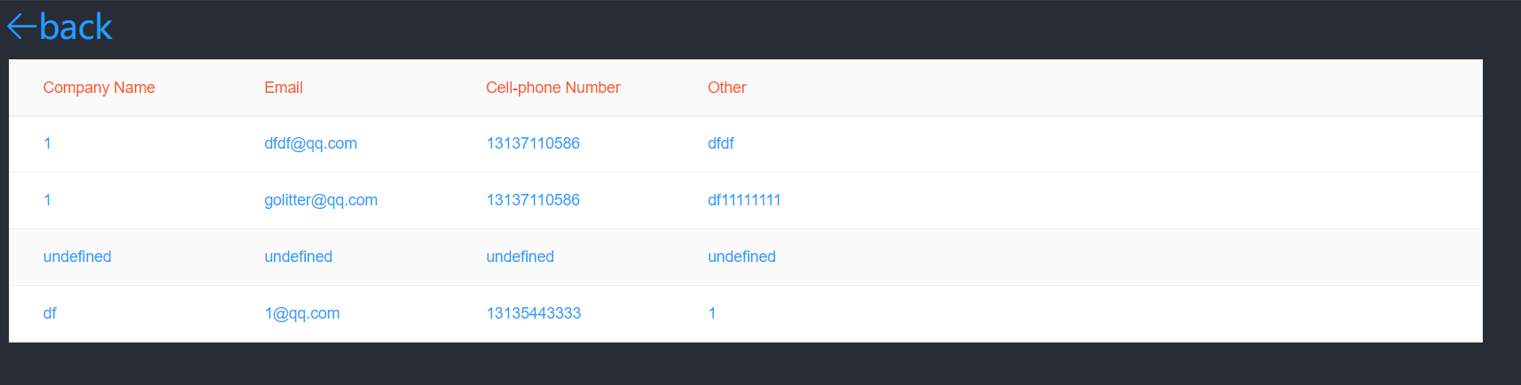



* **Show visitor information in the visitor information bar**

Add a row of tables dynamically after the tbody, combining the length before it.

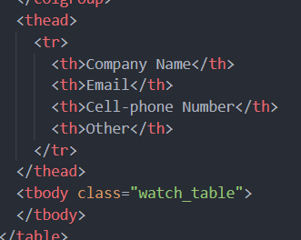

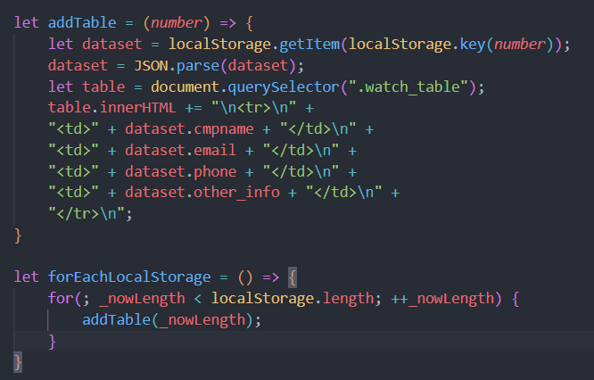

* **The navigation bar is unchanged, switch local pages**

Consider having a local page, clicking on the navigation bar should show the clicked local page. Given that visitors visit this page to see my resume, the "resume" page is set as the default display, while the other two pages, "submit" and "watch", are not shown initially.



When the mouse clicks on the contents of the list, set the local pages to not show, and set the click page to show.

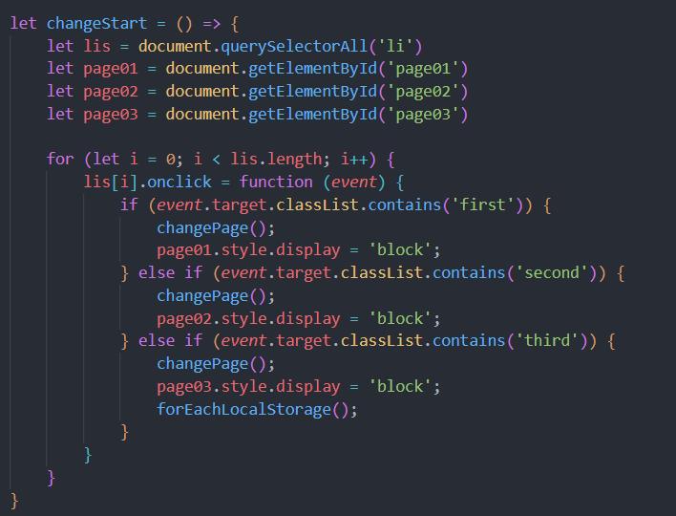

* **Long and Short Resume Switching**

Hide part of my resume content with jQuery's hide(), click the button "More", show it with the show(), and assign the button content to "Less".

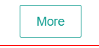

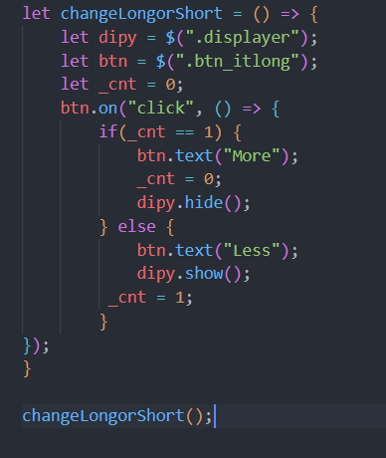

* **Form Verification Feedback**

Prompt for malformed input.

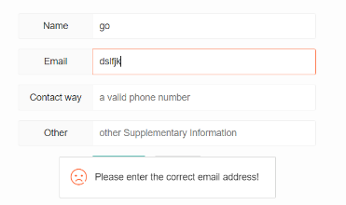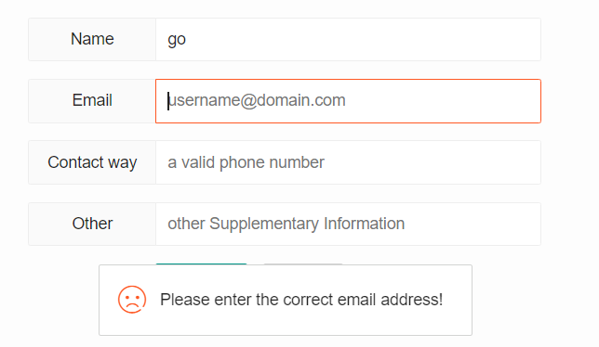

At the same time, make more rigorous judgments about mailbox and mobile phone numbers using custom regular expressions.

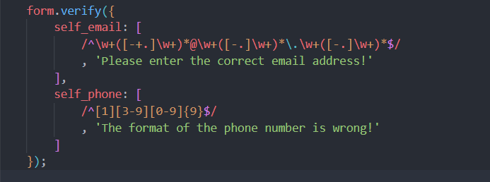

* **Overall Layout**

Layout as a whole with a layui framework

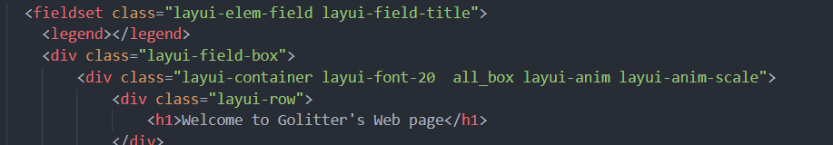

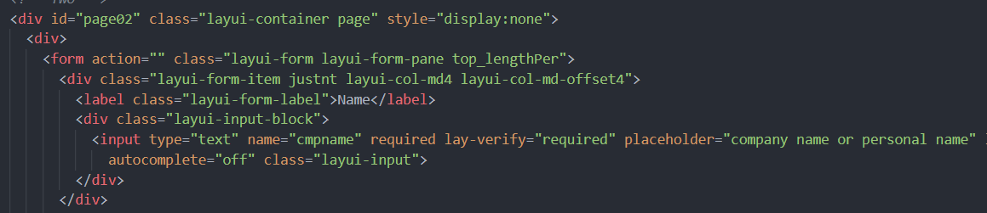

Get a beautiful layout.



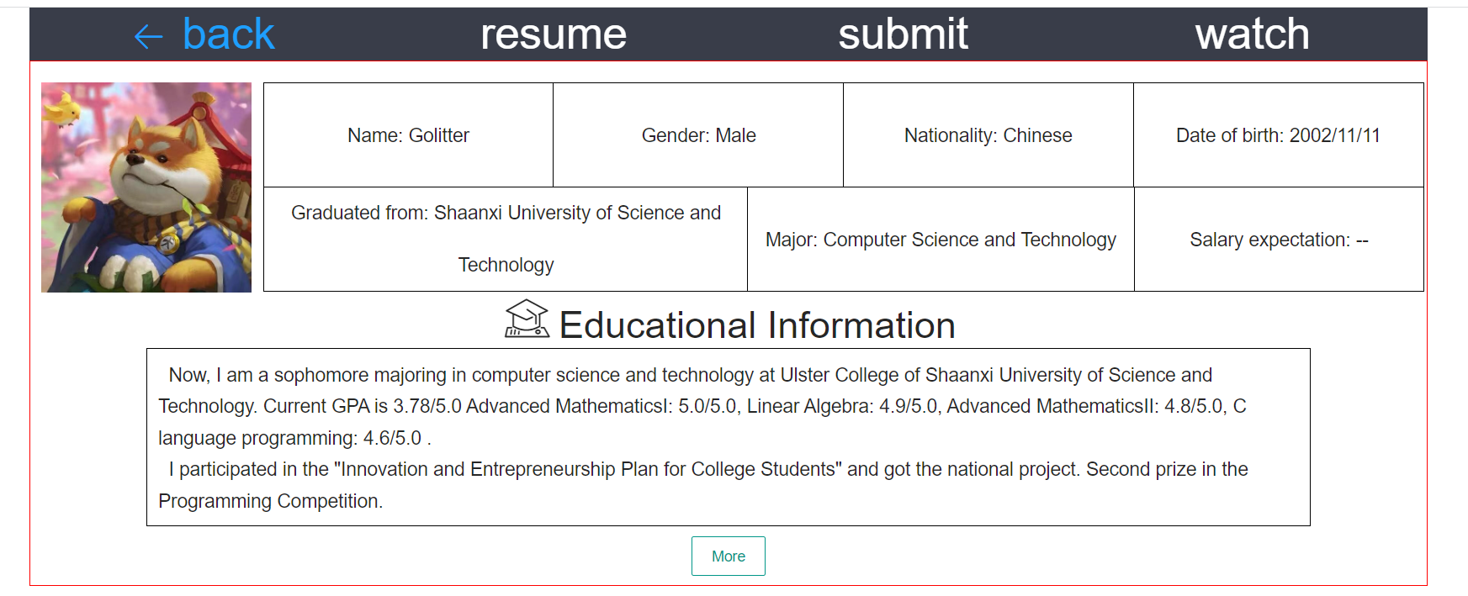

## Reference

(N.d.). <http://layui.winxapp.cn/doc/index.html>

(N.d.). MDN. <https://developer.mozilla.org/zh-CN/>

Application of visual colors in dynamic web page design through affective cognition. (Kuo et al., 2021)

Colour Combinations Every Designer Should Know. ( Perhiniak, 2021)

## Appendix

### Html

#### Image_map.html

<!DOCTYPE html>  
<html lang="en">  
   
<head>  
    <meta charset="UTF-8">  
    <meta http-equiv="X-UA-Compatible" content="IE=edge">  
    <meta name="viewport" content="width=device-width, initial-scale=1.0">  
    <link rel="stylesheet" href="./node_modules/layui/dist/css/layui.css">  
    <link rel="stylesheet" href="./css/image_map_index.css">  
    <script src="./node_modules/jquery/dist/jquery.js"></script>  
    <script src="./node_modules/layui/dist/layui.js"></script>  
   
    <title>image_map</title>  
   
</head>  
   
<body>  
    <div class="profile"></div>  
      <fieldset class="layui-elem-field layui-field-title">  
        <legend></legend>  
        <div class="layui-field-box">  
            <div class="layui-container layui-font-20  all_box layui-anim layui-anim-scale">    
                <div class="layui-row">  
                    <h1>Welcome to Golitter's Web page</h1>  
                </div>  
                <div class="layui-row content_box">  
                  <div class="layui-col-md6 layui-col-md-offset3">  
                    <p>This is golitter's resume, you can click to see  
                    </p>  
                    <p>  
                        <a href="./web_form.html">  
                            <button type="button" class="layui-btn layui-btn-lg layui-btn-radius layui-btn-normal">click</button>  
                        </a>  
                    </p>  
                  </div>  
                </div>          
                <div class="layui-row ">  
                    <div class="layui-col-md2 layui-col-md-offset5">  
                        <hr class="layui-border-green">  
                    </div>  
                  </div>    
   
                <div class="layui-row content_box">  
                    <div class="layui-col-md4 layui-col-md-offset4">  
                        <p>Click to view visitor information.  
                        </p>  
                        <p>  
                            <a href="./view_CV_requested.html">  
                                <button type="button" class="layui-btn layui-btn-radius">see it</button>  
                            </a>  
                        </p>  
                    </div>  
                </div>  
   
                <div class="layui-row">  
                    <div class="layui-col-md4 layui-col-md-offset4">  
                        <hr class="layui-border-cyan">  
                    </div>  
                </div>  
   
                <div class="layui-row content_box">  
                    <div class="layui-col-md4 layui-col-md-offset4">  
                        <p>this is golitter's pdf document, please watch.</p>  
                        <p>  
                            <button type="button" class="layui-btn layui-btn-primary layui-border-red">see it</button>  
                        </p>  
                    </div>  
                </div>  
              </div>  
   
        </div>  
      </fieldset>  
   
</body>  
   
</html>

#### Web_form.html

<!DOCTYPE html>  
<html lang="en">  
   
<head>  
  <meta charset="UTF-8">  
  <meta http-equiv="X-UA-Compatible" content="IE=edge">  
  <meta name="viewport" content="width=device-width, initial-scale=1.0">  
  <link rel="stylesheet" href="./css/web_form_index.css">  
  <link rel="stylesheet" href="./css/web_form_resume_index.css">  
  <link rel="stylesheet" href="./css/web_form_resume_watch.css">  
  <link rel="stylesheet" href="./css/web_form_resume_submit.css">  
  <link rel="stylesheet" href="./node_modules/layui/dist/css/layui.css">  
  <script src="./node_modules/layui/dist/layui.js"></script>  
  <script src="./node_modules/jquery/dist/jquery.js"></script>  
  <title>web_form</title>  
</head>  
   
<body>  
   
  <div class="layui-container">  
    <ul class="nav layui-row">  
      <li class="back"><a style="text-decoration:none; color:#1E9FFF;" href="image_map.html">  
          <i class=" back_button layui-icon layui-icon-return" style="font-size: 30px; color: #1E9FFF;"></i>  
          back  
        </a></li>  
      <li class="first">  
        resume  
      </li>  
      <li class="second">submit</li>  
      <li class="third">watch</li>  
    </ul>  
  </div>  
  <!-- One -->  
  <div id="page01" class="layui-container page " style="display:block">  
    <!-- <h1>resume</h1> -->  
    <div class="layui-row " style="padding-top: 20px;">  
      <div class="profile layui-col-md2 ">  
        <img id="pfl" src="./images/pro.jpg" alt="profile">  
      </div>  
      <div class="layui-col-md10 layui-font-18">  
        <div class="layui-row resume_header " style="text-align:center;">  
          <div class="layui-col-md3 shallowbord">  
            Name: Golitter  
          </div>  
          <div class="layui-col-md3 shallowbord clear_leftBorder">  
            Gender: Male  
          </div>  
          <div class="layui-col-md3 shallowbord">  
            Nationality: Chinese  
          </div>  
          <div class="layui-col-md3 minz shallowbord">  
            Date of birth: 2002/11/11  
          </div>  
          <div class="layui-col-md12">  
            <div class="layui-col-md5 shallowbord_long clear_leftBorder">  
              Graduated from: Shaanxi University of Science and Technology  
            </div>  
            <div class="layui-col-md4 shallowbord">  
              Major: Computer Science and Technology  
            </div>  
            <div class="layui-col-md3 shallowbord">  
              Salary expectation: --   
            </div>  
          </div>  
        </div>  
      </div>  
    </div>  
    <div class="layui-row separation_header layui-font-18 ">  
      <div class="info_header ">  
        <span class="iconfont">&#xe624;</span> <span class="info_title">Educational Information</span>  
        <div class="layui-row">  
          <div class="layui-col-md10 layui-col-md-offset1 info_box ">  
            <p>&nbsp;&nbsp;Now, I am a sophomore majoring in computer science and technology at Ulster College of Shaanxi University of Science and Technology. Current GPA is 3.78/5.0 Advanced MathematicsI: 5.0/5.0, Linear Algebra: 4.9/5.0,   
              Advanced MathematicsII: 4.8/5.0, C language programming: 4.6/5.0 .</p>  
            <p>&nbsp;&nbsp;I participated in the "Innovation and Entrepreneurship Plan for College Students" and   
              got the national project. Second prize in the Programming Competition.</p>  
          </div>  
        </div>  
      </div>  
    </div>  
   
    <div class="layui-row separation_header layui-font-18  ">  
      <div class="info_header ">  
        <button type="button" class="layui-btn layui-btn-primary layui-border-green btn_itlong">More</button>  
      </div>  
    </div>  
   
    <div class="layui-row separation_header layui-font-18  displayer">  
      <div class="info_header ">  
        <span class="iconfont">&#xe975;</span> <span class="info_title">Work Experience</span>  
        <div class="layui-row">  
          <div class="layui-col-md10 layui-col-md-offset1 info_box">  
            <p>&nbsp;&nbsp;Familiar with C/C++, Java, Know python. Can use Linux.</p>  
            <p>&nbsp;&nbsp;At present, I have completed several course designs related to my major, and I have some small tools I usually make in <a href="https://github.com/golitter?tab=repositories" style="color:#01AAED" target="_blank">https://github.com/golitter</a>.</p>  
          </div>  
        </div>  
      </div>  
    </div>  
   
    <div class="layui-row separation_header layui-font-18 displayer">  
      <div class="info_header ">  
        <span class="iconfont">&#xe626;</span> <span class="info_title">Self-evaluation</span>  
        <div class="layui-row ">  
          <div class="layui-col-md10 layui-col-md-offset1 info_box">  
            <p>&nbsp;&nbsp;Have a strong self-motivated, sense of responsibility.</p>  
            <p>&nbsp;&nbsp;Have a strong self-motivated, sense of responsibility. Have a strong curiosity about things,   
              passion for the software industry can be maintained.</p>  
            <p>&nbsp;&nbsp;Have strong learning ability.</p>  
          </div>  
        </div>  
      </div>  
    </div>  
   
    <div class="layui-row separation_header layui-font-18 displayer">  
      <div class="info_header ">  
        <span class="iconfont">&#xe643;</span> <span class="info_title">Other Description</span>  
        <div class="layui-row ">  
          <div class="layui-col-md10 layui-col-md-offset1 info_box">  
            <p>&nbsp;&nbsp;Willing to work overtime</p>  
          </div>  
        </div>  
      </div>  
    </div>  
    <br>  
  </div>  
   
  </div>  
   
   
  <!-- Two -->  
  <div id="page02" class="layui-container page" style="display:none">  
    <div>  
      <form action="" class="layui-form layui-form-pane top_lengthPer">  
        <div class="layui-form-item justnt layui-col-md4 layui-col-md-offset4">  
          <label class="layui-form-label">Name</label>  
          <div class="layui-input-block">  
            <input type="text" name="cmpname" required lay-verify="required" placeholder="company name or personal name" lay-reqText="Can not be empty"  
              autocomplete="off" class="layui-input">  
          </div>  
        </div>  
   
        <div class="layui-form-item justnt layui-col-md4 layui-col-md-offset4">  
          <label class="layui-form-label">Email</label>  
          <div class="layui-input-block">  
            <input type="text" name="email" required lay-verify="self_email" placeholder="username@domain.com" autocomplete="off" class="layui-input">  
          </div>  
        </div>  
   
        <div class="layui-form-item justnt layui-col-md4 layui-col-md-offset4">  
          <label class="layui-form-label">Contact way</label>  
          <div class="layui-input-block">  
            <input type="text" name="phone" required lay-verify="self_phone" placeholder="a valid phone number" autocomplete="off" class="layui-input">  
          </div>  
        </div>  
   
        <div class="layui-form-item justnt layui-col-md4 layui-col-md-offset4">  
          <label class="layui-form-label">Other</label>  
          <div class="layui-input-block">  
            <input type="text" name="other_info" lay-verify="other_info" placeholder="other Supplementary Information" autocomplete="off"  
              class="layui-input">  
          </div>  
        </div>  
   
        <div class="layui-form-item layui-col-md4 layui-col-md-offset4">  
          <div class="layui-input-block">  
            <button class="layui-btn" lay-submit lay-filter="getInfo">submit</button>  
            <button type="reset" class="layui-btn layui-btn-primary">reset</button>  
          </div>  
        </div>  
      </form>  
    </div>  
  </div>  
   
  <div id="page03" class="layui-container page" style="display:none">  
    <h1>watch</h1>  
    <table class="layui-table table_box " lay-even lay-skin="line" lay-size="lg">  
      <colgroup>  
        <col width="200">  
        <col width="200">  
        <col width="200">  
      </colgroup>  
      <thead>  
        <tr>  
          <th>Company Name</th>  
          <th>Email</th>  
          <th>Cell-phone Number</th>  
          <th>Other</th>  
        </tr>  
      </thead>  
      <tbody class="watch_table">  
      </tbody>  
    </table>  
   
  </div>  
   
  <script type="module"></script>  
  <script src="./javascript/web_form_index.js"></script>  
  <script src="./javascript/web_form_resume.js"></script>  
  <script src="./javascript/web_form_submit.js"></script>  
</body>  
   
</html>

#### View_CV_requested.html

<!DOCTYPE html>  
<html lang="en">  
<head>  
    <meta charset="UTF-8">  
    <meta http-equiv="X-UA-Compatible" content="IE=edge">  
    <meta name="viewport" content="width=device-width, initial-scale=1.0">  
   
    <title>view_CV_requested</title>  
    <link rel="stylesheet" href="./css/view_CV_requested.css">  
    <link rel="stylesheet" href="./node_modules/layui/dist/css/layui.css">  
    <script src="./node_modules/layui/dist/layui.js"></script>  
    <script src="./node_modules/jquery/dist/jquery.js"></script>  
</head>  
<body>  
    <div class="placeDiv">  
        <div class="btn_back">  
            <a href="./image_map.html">  
                <i class=" back_button layui-icon layui-icon-return" style="font-size: 30px; color: #1E9FFF;">back</i>  
            </a>  
        </div>  
    </div>  
    <div class="layui-container">  
        <table class="layui-table table_box " lay-even lay-skin="line" lay-size="lg">  
            <colgroup>  
              <col width="200">  
              <col width="200">  
              <col width="200">  
            </colgroup>  
            <thead>  
              <tr>  
                <th>Company Name</th>  
                <th>Email</th>  
                <th>Cell-phone Number</th>  
                <th>Other</th>  
              </tr>  
            </thead>  
            <tbody class="watch_table">  
            </tbody>  
          </table>  
    </div>  
   
    <script src="./javascript/view_CV_requested.js"></script>  
</body>  
</html>

### Css

#### Image_map_index.css

body {  
    background-image:url("../images/2.png");  
    background-size: 100%;  
    background-repeat: no-repeat;  
    color:#1E9FFF;  
}  
h1 {  
    color:#FF5722;  
}  
   
p {  
    margin-bottom: 20px;  
}  
   
.profile {  
    width:50px;  
    height: 50px;  
    position: sticky;  
    top:70px;  
    left:95%;  
    background-image: url("../images/pro.jpg");  
    background-size: 100% 100%;  
    background-repeat: no-repeat;  
    border-radius:50%;  
}  
   
.content_box {  
    height: 100px;  
}  
.all_box {  
    margin-top: 5%;  
    text-align: center;  
}

#### Web_form_index.css

.nav{  
    display: flex;  
    list-style: none;  
    margin-left: auto;  
}  
/* a {  
    text-decoration: none;  
    color:#fff;  
} */  
   
   
li{  
    width: 1200px;  
    height: 50px;  
    line-height: 50px;  
    text-align: center;  
    margin: 0 50px;  
    background-color:#393D49;  
    font-size: 3em;  
    color:#fff;  
    cursor: pointer;  
}  
.page{  
    width: 400px;  
    border: 1px solid red;  
}  
   
.back {  
    color:#1E9FFF;  
}  
   
 

#### Web_form_resume_index.css

.out {  
    box-shadow: 0px 0px 10px 5px #aaa;  
}  
   
#pfl {  
    width: 200px;  
    height: 200px;  
    display: inline-block;  
   
}  
   
.profile {  
    text-align: center;  
}  
   
.back_button {  
    margin-right: 5px;  
}  
.shallowbord {  
    border: 1px solid #000;  
    margin: 0px -1px -1px 0px;  
    height: 100px;  
    line-height: 100px;  
}  
   
   
.shallowbord_long {  
    border: 1px solid #000;  
    margin: 0px -1px -1px 0px;  
    height: 100px;  
    line-height: 50px;  
}  
   
.clear_leftBorder {  
    border-right: 0px;  
}  
.minz {  
    margin-left: 1px;  
    border-left: 0;  
}  
   
.separation_header {  
    margin-top: 10px;  
}  
   
@font-face {  
    font-family: "iconfont";  
    /* Project id  */  
    src: url('../font-family/font_37ue05iz2df/iconfont.ttf') format('truetype');  
}  
   
.iconfont {  
    font-family: "iconfont" !important;  
    font-size: 50px;  
    font-style: normal;  
    -webkit-font-smoothing: antialiased;  
    -moz-osx-font-smoothing: grayscale;  
}  
   
.icon-qita:before {  
    content: "\e643";  
}  
   
.icon-xueli:before {  
    content: "\e624";  
}  
   
.icon-ziwopingjia:before {  
    content: "\e626";  
}  
   
.icon-a-gongzuotaigongzuozhuo-02:before {  
    content: "\e975";  
}  
   
.info_header {  
    height: 30px;  
    line-height: 30px;  
    text-align: center;  
}  
   
.info_box {  
    height:170px;  
    /* text-align: center; */  
    text-align: left;  
    border: 1px solid #000;  
    margin: 0px -1px -1px 0px;  
    padding: 10px;  
}  
   
.info_title {  
    font-size: 2em;  
}  
   
.displayer {  
    display: none;  
}

#### Web_form_resume_submit.css

.justnt {  
    text-align: center;  
}  
   
.layui-form-label{  
    width: 100px;  
}  
.layui-input-block {  
    margin-left: 130px;  
    min-height: 36px  
}  
   
#page02 {  
    height:400px;  
    background-color: rgba(234, 234, 234, 0.1);  
}  
.top_lengthPer {  
    margin-top: 5%;  
}

#### Web_form_resume_watch.css

.table_box {  
    font-size: 30px;  
}

#### View_CV_requested.css

body {  
    background-image:url("../images/2.png");  
    background-size: 100%;  
    background-repeat: no-repeat;  
}  
   
tr>th {  
    color:#FF5722;  
}  
tr>td {  
    color:#1E9FFF;  
}  
   
.placeDiv {  
    height:40px;  
}  
   
.btn_back {  
    width:100px;  
    height:40px;  
    font-size: 30px;  
    margin-top: 60px;  
    margin-left: 100px;  
}

### javaScript

#### web_form_index.js

let _nowLength = $("tr").length -1;  
   
let addTable = (number) => {  
    let dataset = localStorage.getItem(localStorage.key(number));  
    dataset = JSON.parse(dataset);  
    let table = document.querySelector(".watch_table");  
    table.innerHTML += "\n<tr>\n" +  
    "<td>" + dataset.cmpname + "</td>\n" +  
    "<td>" + dataset.email + "</td>\n" +  
    "<td>" + dataset.phone + "</td>\n" +  
    "<td>" + dataset.other_info + "</td>\n" +  
    "</tr>\n";  
}  
   
let forEachLocalStorage = () => {  
    for(; _nowLength < localStorage.length; ++_nowLength) {  
        addTable(_nowLength);  
    }   
}  
   
let changeStart = () => {  
    let lis = document.querySelectorAll('li')  
    let page01 = document.getElementById('page01')  
    let page02 = document.getElementById('page02')  
    let page03 = document.getElementById('page03')  
   
    for (let i = 0; i < lis.length; i++) {  
        lis[i].onclick = function (event) {  
            if (event.target.classList.contains('first')) {  
                changePage();  
                page01.style.display = 'block';  
            } else if (event.target.classList.contains('second')) {  
                changePage();  
                page02.style.display = 'block';  
            } else if (event.target.classList.contains('third')) {  
                changePage();  
                page03.style.display = 'block';  
                forEachLocalStorage();  
            }  
        }  
    }  
}  
   
let changePage = () => {  
    document.querySelectorAll('.page').forEach(el => {  
        el.style.display = 'none'  
    });  
}  
   
changeStart();

#### web_form_resume.js

let changeLongorShort = () => {  
    let dipy = $(".displayer");  
    let btn = $(".btn_itlong");  
    let _cnt = 0;  
    btn.on("click", () => {  
        if(_cnt == 1) {  
            btn.text("More");  
            _cnt = 0;  
            dipy.hide();  
        } else {  
            btn.text("Less");  
            dipy.show();  
         _cnt = 1;  
        }  
});  
}  
   
changeLongorShort();

#### web_form_submit.js

let sumObject = localStorage.length;  
   
let form_verify = layui.use('form', function () {  
    var form = layui.form;  
   
    form.verify({  
        self_email: [  
            /^\w+([-+.]\w+)*@\w+([-.]\w+)*\.\w+([-.]\w+)*$/  
            , 'Please enter the correct email address!'  
        ],  
        self_phone: [  
            /^[1][3-9][0-9]{9}$/  
            , 'The format of the phone number is wrong!'  
        ]  
    });  
   
    form.on('submit(getInfo)', function (data) {  
        layer.msg('Successful submission');  
   
        let _objName = `key${sumObject++}`;  
        localStorage.setItem(_objName, JSON.stringify(data.field));  
        console.log(localStorage);  
        // return false;  
    });  
});  
 

#### view_CV_requested.js

let _nowLength_CV = 0;  
   
let addTable = (number) => {  
    let dataset = localStorage.getItem(localStorage.key(number));  
    dataset = JSON.parse(dataset);  
    let table = document.querySelector(".watch_table");  
    table.innerHTML += "\n<tr>\n" +  
    "<td>" + dataset.cmpname + "</td>\n" +  
    "<td>" + dataset.email + "</td>\n" +  
    "<td>" + dataset.phone + "</td>\n" +  
    "<td>" + dataset.other_info + "</td>\n" +  
    "</tr>\n";  
}  
   
let forEachLocalStorage_CV = () => {  
    for(; _nowLength_CV < localStorage.length; ++_nowLength_CV) {  
        addTable(_nowLength_CV);  
    }   
}  
   
forEachLocalStorage_CV();